FAITH UNITED METHODIST CHURCH
CHRIST THE KING SUNDAY
November 26th, 2017~9:30 A.M.

Welcome to Faith United Methodist Church. It is our heart and desire to engage the community of Waseca with the Gospel of Jesus Christ, equip those who respond to be the next generation of disciples of Jesus Christ and empower them to go into the world as partners with God for the healing of the world.

WELCOME AND GREETINGS
*CALL TO WORSHIP .........................................................................................................................
L: Jesus said: "I was hungry and you gave me food, I was thirsty and you gave me something to drink.
All: Let us act justly.
L: "I was a stranger and you welcomed me, I was naked and you gave me clothing."
All: Let us love tenderly.
L: "I was sick and you took care of me, I was in prison and you visited me."
All: Let us walk humbly with our God.
*OPENING HYMN............."Softly and Tenderly Jesus is Calling"...........UMH No. 348
*OPENING PRAYER.......................................................................................................[UNISON]
Jesus, we come to you as children. Help us to see one another with new eyes, to hear one another with new ears, to love one another with new hearts. Amen.

PSALM 100................................................................................................................UMH No. 821

ANTHEM .........................................“In Christ Alone”.............................................Faith Choir

OLD TESTAMENT LESSON.......................................................Ezekiel 34: 11-16, 20-24

For thus says the Lord God: I myself will search for my sheep and seek them out. As shepherds seek out their flocks when they are among their scattered sheep, so I will seek out my sheep. I will rescue them from all the places to which they have been scattered on a day of clouds and thick darkness. I will bring them out from the peoples and gather them from the countries, and will bring them into their own land; and I will feed them on the mountains of Israel, by the watercourses, and in all the inhabited parts of the land. I will feed them with good pasture, and the mountain heights of Israel shall be their pasture; there they shall lie down in good grazing land, and they shall feed on rich pasture on the mountains of Israel. I myself will be the shepherd of my sheep, and I will make them lie down, says the Lord God. I will seek the lost, and I will bring back the strayed, and I will bind up the injured, and I will strengthen the weak, but the fat and the strong I will destroy. I will feed them with justice.

Therefore, thus says the Lord God to them: I myself will judge between the fat sheep and the lean sheep. Because you pushed with flank and shoulder, and butted at all the weak animals with your horns until you scattered them far and wide, I will save my flock, and they shall no longer be ravaged; and I will judge between sheep and sheep.

HYMN OF PRAISE.....................“It's Me, It's Me, O Lord”.............................UMH No. 352

GOSPEL LESSON..........................................................................................Matthew 25: 31-46

"When the Son of Man comes in his glory, and all the angels with him, then he will sit on the throne of his glory. All the nations will be gathered before him, and he will separate people one from another as a shepherd separates the sheep from the goats, and he will put the sheep at his right hand and the goats at the left. Then the king will say to those at his right hand, 'Come, you that are blessed by my Father, inherit the kingdom prepared for you from the foundation of the world; for I was hungry and you gave me food, I was thirsty and you gave me something to drink, I was a stranger and you welcomed me, I was naked and you gave me clothing, I was sick and you took care of me, I was in prison and you visited me.' Then the righteous will answer him, 'Lord when was it that we saw you hungry and gave you food, or thirsty and gave you something to drink? And when was it that we saw you a stranger and welcomed you, or naked and gave you clothing? And when was it that we saw you sick or in prison and visited you?' And the king will answer them, 'Truly I tell you, just as you did it to one of the least of these who are members of my family, you did it to me.' Then he will say to those at his left hand, 'You that are accursed, depart from me into the eternal fire prepared for the devil and his angels; for I was hungry and you gave me no food, I was thirsty and you gave me nothing to drink, I was a stranger and you did not welcome me, naked and you did not give me clothing, sick and in prison and you did not visit me.' Then they also will answer, 'Lord, when was it that we saw you hungry or thirsty or a stranger or naked or sick or in prison, and did not take care of you?' Then he will answer them, 'Truly I tell you, just as you did not do it to one of the least of these, you did not do it to me.' And these will go away into eternal punishment, but the righteous into eternal life."

L: This is the Word of God for the People of God
All: THANKS BE TO GOD.

MESSAGE ............................................."Faith is a Verb"...............................Rev. Jon Schultz

JOYS AND CONCERNS

OFFERING/PRAYER

*CLOSING HYMN............................................“Pass It On”................................UMH No. 572

*BLESSING AND BENEDICTION
EXIT MUSIC

REMEMBER OUR CHURCH FAMILIES IN YOUR PRAYERS…
Remember our church members & friends who are less mobile and are unable to join us as often as they would like, including:
Colony Court Memory & Care Suites: Ann Swenson, Dick Westrum
Colony Court: Ardella Draheim, Nina Youngberg, Peter Fog, Leona Quast,
Muriel Jenkins, Fern Papke
Lakeshore Inn: Florence Gutknecht, Liz Corchran
Latham Place: Lucille and George Kubista, Elaine Westrum
Oaklawn Health Care Center: Jim Keller
Koda Living Community: Chuck Youngberg
Prayer Requests from Sunday: Leona Quast, Bruce Born, Don Paulson, Becky Tristan and her family, Fern Papke, Robert and Lori Ferry, Neal Schauer, Arth Family, Les and Marie Wells.

ANNOUNCEMENTS

CONFIRMATION - Every 1st and 3rd Wednesdays.

SERMON NOTE OUTLINES are on the table in the Narthex.

YOUTH GROUP - We will not meet in November .


Hanging of the Greens: It's time to decorate for Christmas. Please join us today, November 26th, starting after Fellowship. We will be decorating various areas of our church to help spread the joy and the colors of the advent season throughout. Many hands make light work, so please come and lend YOUR HANDS! All are welcome and can come for a short time or a long time!

Please note -- Stacy True, Administrative Assistant, will be out of the office on Tuesday, November 28 and will be out of the office December 4 through 7.

Newsletter Folding - Newsletter folding is scheduled for Wednesday, November 29 at 10:00 a.m. in the church office. Newsletter folding will be scheduled the fourth Wednesday of the month at 10:00 a.m., or occasionally the fifth Wednesday depending how the calendar falls. Watch the bulletin and calendar for future folding dates. Please join us if you are able.
Note From the Janitor's Closet: Please let me know if there is anything coming up in the months of January, February and March that I need to be aware of and that pertain to custodial duties. I will be out those months having knee replacement. Jon Schultz will be filling in for me.

Leave any notes in my mailbox so I may put them on my calendar. -- Bob

If you are cleaning out closets, keep in mind that the Relay for Life Garage Sale will be held on Saturday, May 5. Your donations would be greatly appreciated. If you have questions about donations, please contact Vada Dahnert or Dave Baldini.

New Church Directories are available. You may pick one up in the back of the Sanctuary or in the church office. We are asking that you please just take one per household at this time.

CHRISTMAS EVE CANDLELIGHT SERVICE WILL BE ON DECEMBER 24 AT 4:30 P.M. THERE WILL BE NO SUNDAY MORNING SERVICE ON DECEMBER 24.

UMW Officers for 2018
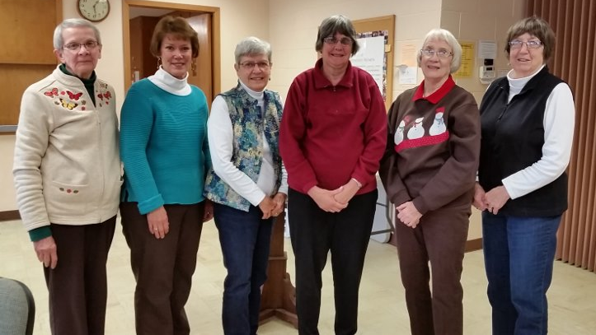

Sandy Voshell, treasurer
Shirley Hansen, president
Lorraine Wick, nominations
Linda Griffin, secretary
Janet Welch, communications
Roberta Walker, vice president

THIS WEEK AT A GLANCE...

11/26/2017 (Sun.) Pancake Mix Sunday
Pastor Victor on Vacation
9:30 a.m. - Worship Service with Rev. John Schultz
10:30 - 11:30 a.m. - Fellowship

11/27/2017 (Mon.) Faith Messenger Mailed This Week
Pastor Victor on Vacation
3:00-4:30 p.m. -Conversation, Bible & Friends (*LV Room)
5:00-8:30 p.m. - Terra LaMont Intro to Essential Oils Class (**FH)

11/28/2017 (Tues.) Administrative Assistant Out of Office

11/29/2017 (Wed.) 10:00 a.m. - Newsletter Folding (Church Office)
7:00 p.m. - Choir Practice

12/03/2017 (Sun.) 1st Sunday of Advent
Birthday Sunday
9:30 a.m. - Worship with Communion
10:00 a.m. - Sunday School
10:30 - 11:30 a.m. - Fellowship

*Lakeview Room **Fellowship Hall

